**Tennis**

1. Delete Sprite 1 (the cat)
2. Create two variables (redScore and blueScore) and make them visible on the stage.
3. Add the Tennis Ball sprite to your project from the sprite library.
4. Create a sprite for the red paddle (name it Red) as a bitmap.

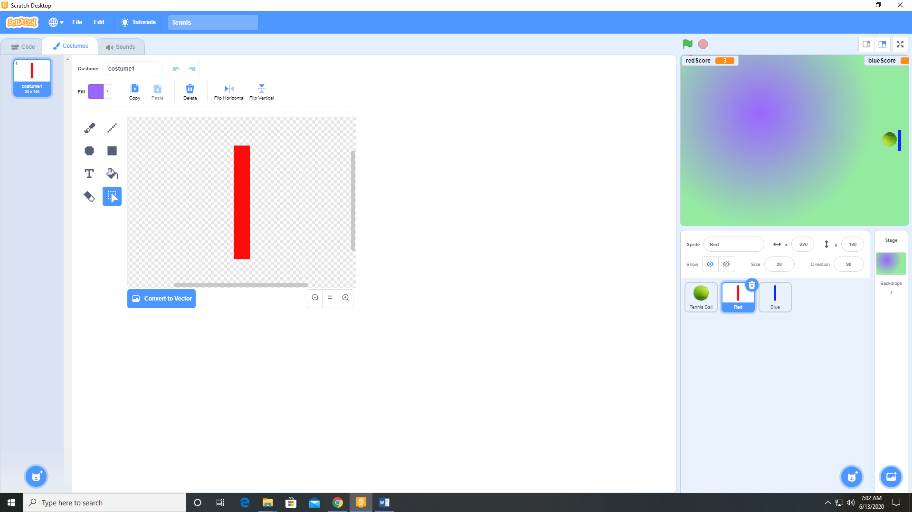

1. Create a sprite for the blue paddle (name it Blue) as a bitmap.

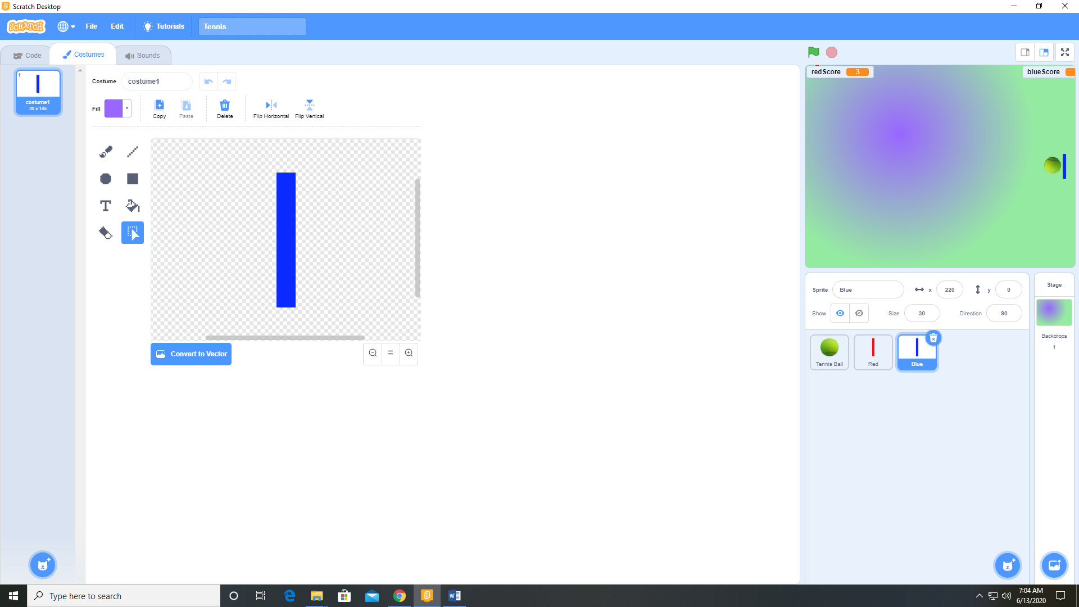

1. With the Tennis Ball sprite selected, and the Chord 2 sound from the sound library.
2. Add the following code to the Tennis Ball sprite.

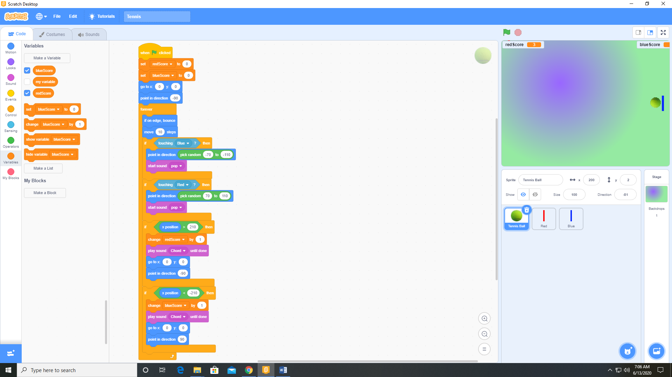

1. Add the following code to the Red sprite.

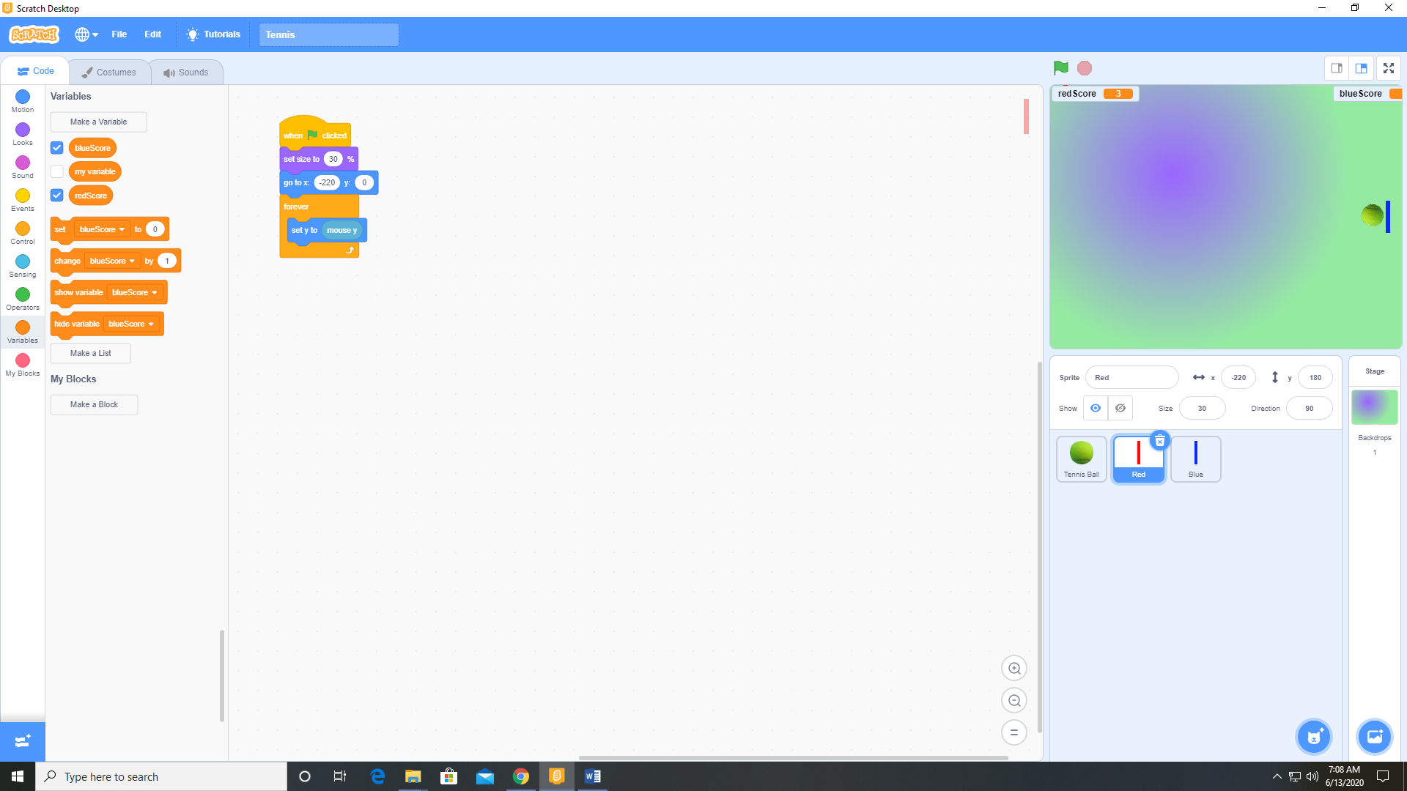

1. Add the following code to the blue sprite

